**SWE230-Team Project Final Evaluation**

|  |  |  |  |
| --- | --- | --- | --- |
| **Project Title: Aloura: Unlock the Power of Scent - Fragrance E-commerce** | | | **Team Code: 4** |
| **Items** | **Weight** | **Grade** | **Notes** |
| **Project Grade** | | |  |
| Deployment & Domain name | 5 |  |
| MVC & Routing | 10 |  |
| Authentication (Security & Privacy) | 5 |  |
| Sessions | 5 |  |
| Uploading Files | 5 |  |
| Error Handling | 5 |  |
| Data Validation (Frontend + Backend) | 10 |  |
| CRUD operations for (users, products, etc…) | 15 |  |
| AJAX/Fetch | 5 |  |
| Application UI/UX quality | 5 |  |
| Innovation | 10 |  |
| **Bonus** | | |
| HTTPS Support | 5 |  |
| Localization | 5 |  |
| External API | 5 |  |
| Responsive UI | 5 |  |
| Pagination | 5 |  |
| **Project Total Grade** | **80** |  |

# **Team Individual Evaluation and Final Grade**

|  |  |  |  |  |  |
| --- | --- | --- | --- | --- | --- |
|  | **ID** | **Name as in MIU ID** [Sorted in ascending order] | **Discussion**  **(10)** | **GitHub**  **(10)** | **Total (100)** |
| **1** | 2023/04892 | Antoni Ashraf Gamil Youssef Mikhaiel |  |  |  |
| **2** | 2023/00428 | Mohamed Hesham Abdulla Elziat |  |  |  |
| **3** | 2023/00799 | Nabil Ramy Farid Francis |  |  |  |
| **4** | 2023/01480 | Ramy Ahmed Shawky Slait |  |  |  |
| **5** | 2023/04145 | Seif Mohamed Fouad Mohamed Makled |  |  |  |

Assessor Name: Assessor Signature:

# **Project Information**

**Live Application URL: https://aloura.live/**

**Live Application URL QR Code:**



# Abstract

Aloura is a comprehensive e-commerce platform specializing in premium fragrances, designed to revolutionize the online

fragrance shopping experience. Built using Node.js with Express framework and MongoDB database, the platform offers a

sophisticated user interface with EJS templating and responsive design. Key features include user authentication with JWT

tokens and an intelligent chatbot powered by Google's Gemini AI for personalized customer support, and a comprehensive

fragrance quiz system that provides personalized recommendations based on user preferences. The platform supports

complete e-commerce functionality with shopping cart management, secure checkout processes, order tracking, user

reviews system, and administrative dashboard for inventory and user management. Additional features include gift

wrapping services, dark mode support, SMS/email notifications and Nodemailer, file upload capabilities with Multer, and

responsive design optimized for all devices. The project demonstrates modern web development practices with API

architecture, proper error handling, and scalable database design, serving as a real-world startup solution for the fragrance

retail industry.

# GitHub repository

**GitHub URL & QR Code: https://github.com/mohamedelziat50/Aloura-MIU**

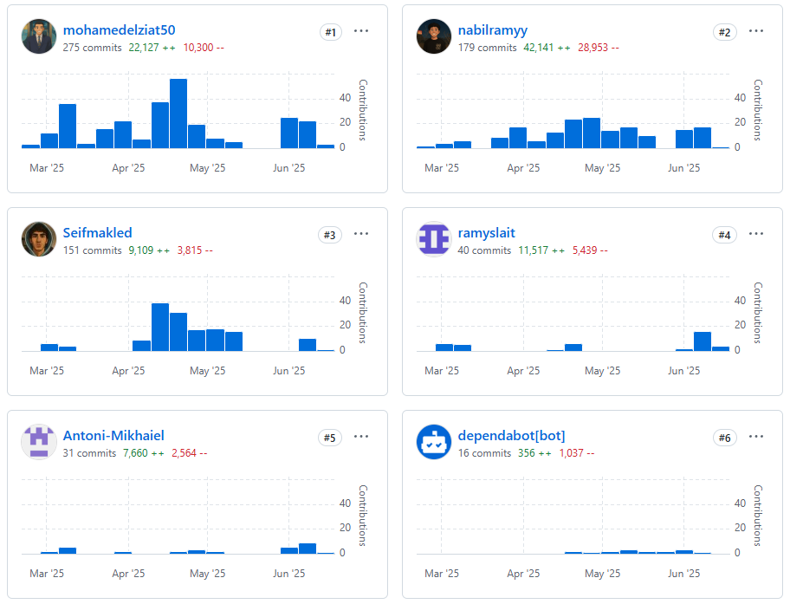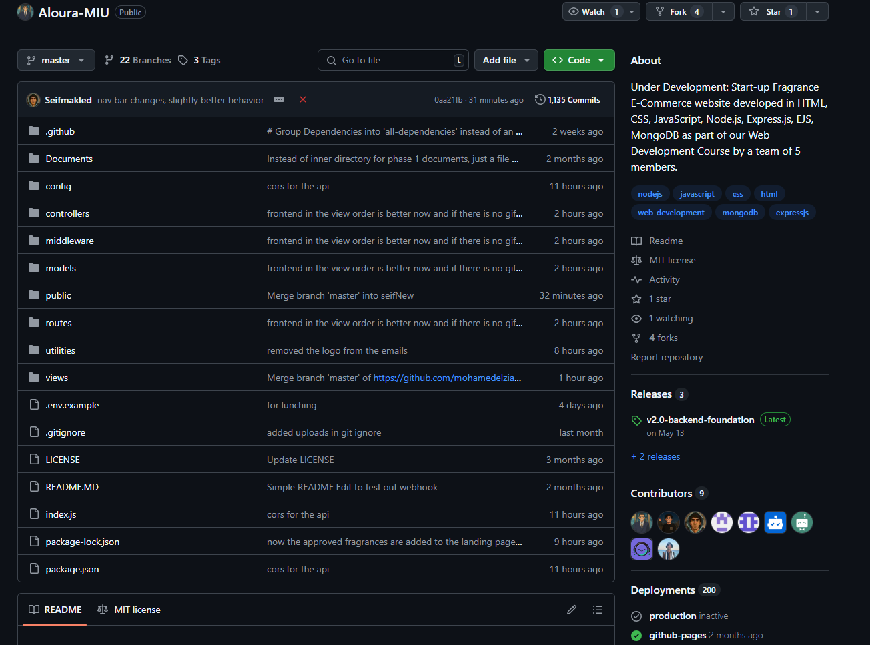

Include screenshots of your project GitHub repository and contributors’ insights showing each team member commits. Make sure to use the light theme so the screenshots are clear.

# Tasks distribution:

|  |  |  |  |  |  |
| --- | --- | --- | --- | --- | --- |
| ID | Task name | Description | Start date | Duration in hours | Assigned to |
| **1** | Responsiveness | All pages are responsive and adapt to all device sizes |  |  | All Members |
| **2** | Admin Dashboard | Admin dashboard with analytics & CRUD operations. |  |  | All Members |
| **3** | Fragrance & Gifting Pages | Front-end for fragrance and gifting product pages. |  |  | Ramy |
| **4** | Fragrance Quiz & Our Story Pages | Front-end for the fragrance quiz and about us pages. |  |  | Seif  Mohamed H. |
| **5** | Index & Collections Pages | Front-end for the landing page and themed collections. |  |  | Antoni  Seif |
| **6** | CRUD for Gifting | Back-end for creating, updating, and deleting gift items and options. |  |  | Ramy |
| **7** | CRUD for Fragrances | Back-end for fragrance product management, including images and attributes. |  |  | Antoni  Nabil |
| **8** | CRUD for Reviews | Back-end for user reviews, moderation, and admin approval. |  |  | Mohamed H.  Seif |
| **9** | Partials | Implementation of navigation bar and footer, etc. as reusable partials. |  |  | All Members |
| **10** | All Fragrances Page | Front-end for displaying and searching all fragrances. |  |  | Mohamed H. |
| **11** | Order Management | Back-end and front-end for order creation, order history, and admin order control. |  |  | Mohamed H.  Ramy  . |
| **12** | User Account & Profile Pages | Front-end for User account page, profile management, and order/review history. |  |  | Mohamed H.  Ramy |
| **13** | CRUD for Users | Back-end for user management, including admin controls. |  |  | Nabil |
| **14** | Cart Functionality | Cart operations for adding, updating, and removing products and gifts. |  |  | Nabil  Ramy |
| **15** | Middleware | Authentication, cookies, file upload (multer), and security middleware. |  |  | Nabil  Antoni |
| **16** | Subscriber List & Campaigns | Admin management of subscribers and marketing campaigns. |  |  | Antoni  Nabil |
| **17** | Deployment & HTTPS | AWS Deployment setup, Domain Name, and HTTPS configuration for secure access. |  |  | Nabil  Antoni |
| **18** | Utilities | Email and SMS utilities for notifications, verification, and password reset. |  |  | Nabil |
| **19** | Chatbot Integration | AI(Gemini)-powered chatbot for user support and product recommendations. |  |  | Nabil |
| **20** | Dark Mode & Internationalization | Dark mode toggle for all pages and (planned) multi-language support. |  |  | Mohamed H. |